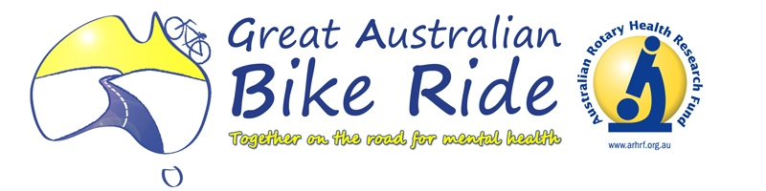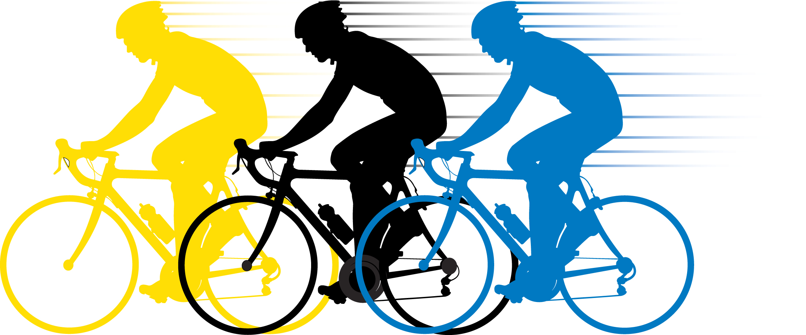

I wanted to send you a brief note to thank you so much for your generosity and support when we arrived in your area during the bike ride. The object of our ride through the district was to keep the Great Australian Bike Ride momentum going whilst it was on its layover in Sydney. I know we more that kept the flag flying from the attention it gained from the interest of local press. It is times like this where a true team spirit is needed to make an event a success and our District can certainly hold its head up high.

It would be remiss of me if I didn’t say a special thankyou to Dave Humphry from St Mary’s Rotary Club for riding with me the whole trip. To have a partner to commiserate with through the aches and pains, hills and aggressive motorists is a Godsend.
Also thanks to Rod McDougall and Kevin Beltrame from Strathfield Rotary Club, Peter Wilson and his friend Alan from Holroyd Rotary Club and Roger French from Wallacia / Mulgoa Rotary Club for riding Stages on Friday.
On Saturday we had Malcolm Nicholson (bless his tired legs) from Katoomba Rotary Club, Horst Hauser and his friends Gary and Kevin from Windsor Rotary Club and Pennie Holley from Blacktown City Rotary Club that joined in and rode stages with us on the Saturday.
An extra special thank you to the two support drivers Bob Bensley and Bob Gardiner for being there for us the entire trip. To sit in a car either shielding us in the difficult stages or letting all of you know as we were getting close is not the easiest of jobs, especially at times when they have to drive at speeds of as low as 15 to 20 kph. They were also there for us to offer words of support when needed and to keep us on time all of which is certainly an import role. Whilst on the support crew, thankyou to John Wilson for standing by and being ready to go on the Friday morning and also for being at Blacktown on the return.

To have seen all your smiling faces and support from your members at each of the stops was not only heart-warming but uplifting as the legs got more tired and the energy levels started to wane. During the ride we clocked just over192 kms riding, (76 kms on Friday and 116 kms on Saturday), and were in the saddle for a little under 10 hours. We uplifted the bikes twice, once between Strathfield and Bankstown on Friday and once between Penrith and Agnes Banks on Saturday for safety reasons.

Finally I want to express our thanks to Australia Rotary Health and District Officers for their support at the start of the event, during the event and at the conclusion. They took precious time out of their very hectic and harrowing schedules to be there for us. CEO Joy Gillett, GABR Co-ordinator PDG Dick White, Past Vice Chairman PDG Alan Grady, Director PDG Phil Lacey and District Governor Elect Paul Reid

On behalf of Australian Rotary Health and the Great Australian Bike Ride well done District 9690 we really showed what a team effort could achieve.

My Sincerest thanks.

Melvin Gray (Mel)
Rotary Club of Blacktown City

