 Rotary Club of Strathfield
Website: www.rotarnet.com.au/strathfield
Bulletin 2003/4

Edition Number 21  Wednesday, 3 December, 2003  CLUB PRESIDENT  Keith Stockall |  | PRESIDENT-ELECT  Keith Byrn  CLUB SECRETARY  Kevin Freund  CLUB TREASURER  Allan Petersen


ROTARY GRACE

O Lord and Giver of all good
We thank You for our daily food
May Rotary friends and Rotary ways
Help us to serve You all our days

President's Pieces

Hello fellows,

Last Friday night I attended the District Governor’s monthly President’s meeting at Penrith Panthers together with Lillian. This was the last President’s meeting for this year and last one (hopefully) to be held at Panthers. The next meeting will be 20 February 2004 and will be held at the new buildings of the Northcott Society.

Terry Davies from the Rotary Foundation gave another excellent presentation on the work of the Foundation. He also provided information of how we can get involved with some matching grant projects in the Philippines, such as anti- tuberculosis vaccinations for new born babies, computers for I elementary school, hepatitis “B” vaccinations and development of a water system.

A team of members for the GSE team to travel to Houston Texas has been selected. As the team to travel consists of only 3 members, a meeting this weekend, just past, was to decide on who will be the final team members and who will be a reserve member. The candidates are from the following clubs, Hawkesbury, Padstow, Parramatta City, Springwood and Prospect.

The incoming GSE team from Houston arrives in Sydney on 4 March 2004 and will attend the District Conference at Gosford.

While talking about the District Conference there are now 2 members of our club of 60 who have registered for the Conference, Kevin Beltrame and myself. To assist the Rotary Club of Holroyd, the organising club, with their planning and budgeting, I would urge members to register early.

There was also a presentation about the Rotarians Against Malaria (RAM) program and are willing and able to attend our club to tell us more about the program. A startling statistic from the presentation was that someone in the world dies every 20 seconds as a result of malaria.

Duncan Berriman from the Springwood Club spoke about the benefits of the Student Exchange program. He also reminded us that the exchange students in the district are generally available to attend as guest speakers at any time to provide an insight into experiences of living attending school in a foreign country.

John Heels the District Child Protection Officer provided more details of pending child protection Legislation intended to cover volunteers working with children. As advised previously, District 9690 along with 3 other volunteer organistaions have agreed to trial the program conducted by the Commission for Children and Young People. This means that as from 28 November 2003 all Rotarians and people associated with Rotary working with young people under the age of 18 MUST complete the new documentation. This program is not retrospective. The Children’s Commission does not require the participating organisations to submit the new documentation prior to 28 November 2003.

I will be passing the new child protection guidelines to our President Elect Keith Byrn and also to Youth Services Director Kevin Beltrame for implementation.

Last Saturday we had another attempt to raise funds for charity by holding a sausage sizzle at Dan Murphy’s, Enfield. Whilst the day was financially positive this time it could have been better. I wish to thank Shirley once again for coordinating the event, Brian Johnson, Grahame True and Steve for giving up their time for “service above self”. Many thanks to George Helou for positioning the trailer to Enfield and also to Grahame for allowing me to use his van to tow the trailer back to Mrs. Macs.

Reminder, Christmas Carols this Saturday 6 December.

Have a good week

Keith

Tonight’s Meeting
AGM and the election of members for Keith Byrn’s Board

Member’s Announcements
Vicki Wybrow has sent in her resignation from the Strathfield Rotary Club.

Sorry fellows, but I was away in Wagga Wagga last week and with the resignation of Vicki Wybrow I have had to put this bulletin together in a hurry.

Angel0

--------------------------------------
The BBQ at Dan Murphy’s was held last Saturday. BBQ reporter Keith Stockall has included a report in his weekly message and photos at the end.

The Club’s Xmas Meeting will be held at Viscardi’s Restaurant (Le Montage) Leichhardt on the 10th of December 2003. President Keith and Sal Tosto are arranging a good night.

--------------------------------------

The RTA Cycle Ride was on Sunday 30 November, a report from our cycling reporter Steve Taylor.

Another new champ in the club after RTA ride

The Strathfield Rotary Cycling Group were at it again last Sunday with Pres Keith (and family), Kevin Beltrame, Bill Carney, Rod McDougall, Alan Taylor and your humble scribe taking part in the RTA sponsored ride from St Leonards Park North Sydney to Parramatta Park. Missing in action were regulars Euan Watson (although he joined us later for a mini ride home), Kevin Freund, and Rick Collins.

Unlike three weeks ago on the Gong ride where Kevin Beltrame prevailed, Bill Carney got a breakaway at some traffic lights, sprinting away and completing the 48km in 1hr 44minutes, with Kevin, Rod and Allan some minutes behind.

My own claim to fame is finishing AHEAD of Pres Keith (probably for the one and only time) because he was doing the right thing and riding with his daughter and son in law. The weather was fantastic, the route well organised and promoted and apparently over 6,000 riders took part.

On the subject of bike rides the bike ride committee is having its first meeting with SOPA this coming Friday, to organise the 2004 ride in Sydney Olympic Park.
Wish us luck and keep the first weekend in May next year free please.

PP Steve

Celebrations!

Anniversaries

25th November
Roger and Janice Vince

30th November
Allan and Kate Teal

8th December
Rod and Maree McDougal

Birthdays

28th November
Rod McDougall
29th November
Eric Khu

3rd December
Roger Vince
6th December
Peter Harries
Keith Stockall



The BBQ at Dan Murphy’s last Saturday
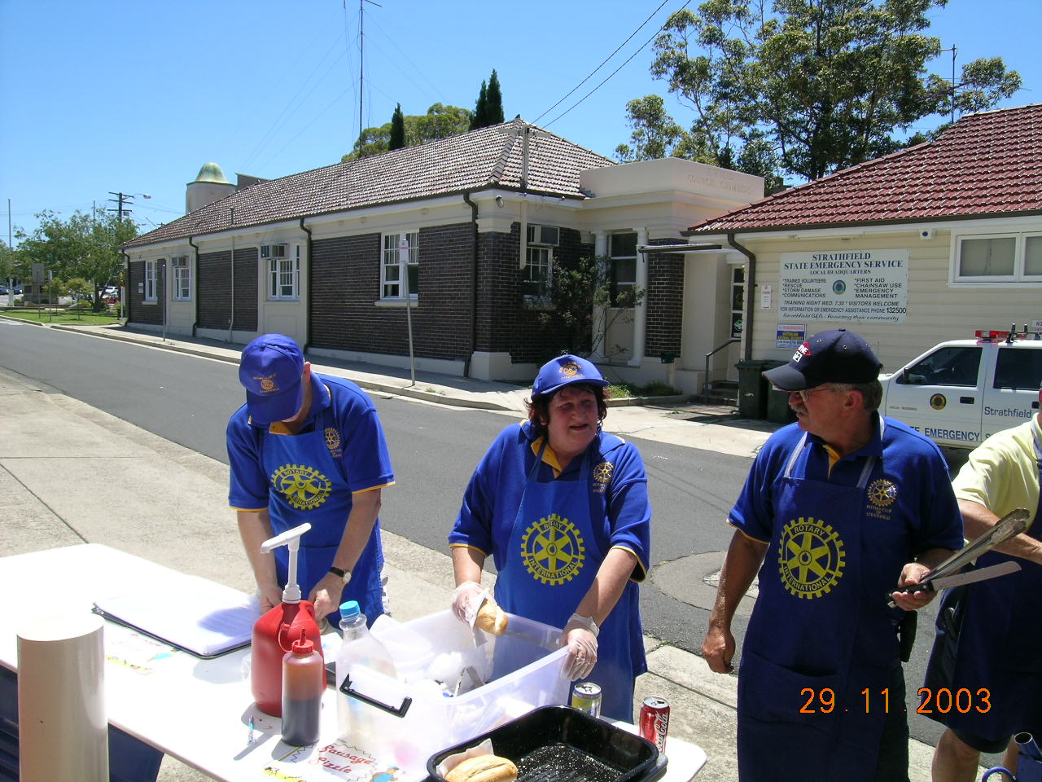 | 