Weekly Bulletin





The Rotary Club of Strathfield

PRESIDENT George Hallworth Edition Number: 11
Wednesday 14th September 2005

Website: http://www.rotarnet.com.au/strathfield
September is New Generations Month

President George’s Chit Chat
********************************
Effort rewarded? Yes, in spades. Brian Johnson and Grahame True excelled in the presentation of the Police Officer of the Year Awards last Wednesday evening. Guest of honour, Police Commissioner, Ken Moroney told of how important these evenings were to the Police Force. There were many comments from police officers present of how much the awards were valued and appreciated. The community recognition of the great job our police force does was also an important ingredient of the Police Awards. The visual recognition of sponsors was a welcome initiative of Rod McDougal. M.C. Grahame kept the meeting moving along. So well done Grahame and Brian.

I recently attended a community forum with four other citizens, the Mayor and General Manager. Topics were quite wide ranging and included traffic management, Parramatta Road development and “Port Enfield”. The later being the main area of discussion. It would seem to be mainly in the Auburn Municipal council area but of great concern to Strathfield residents. If any Rotarian has a concern about the future direction of Strathfield/Homebush I would be glad to raise the matter at the next meeting.

Our thanks must go to Ray Wilson for organising another successful Golf Day last Thursday. Perfect golfing weather. A well attended event and reports of a great day had by all.

Until next week - enjoy Rotary

President George.
To-Night’s Guest Speakers
*****************************
Keith Byrn and Warren Abbott
Implications of the new NRMA Insurance Scheme
Congratulations
*****************************

Birthdays
14/09/2005 George Helou
16/09/2005 Paul Giammarco
21/09/2005 Megan Tarrant

Anniversaries
16/09/2005 Alan & Adrienne Taylor
Last Week’s Guests
*****************************
Deputy Commissioner Bob Waites & Sue
Commander Catherine Byrne, Burwood Command
Commander Allan Harding, Flemington Command
Barbara Perry, State Member for Auburn
Bill Carney, Mayor of Strathfield
David Wieley, Mayor of Burwood, and Angela
Peter Wilson, District Vocational Chairman & Lynne
Last Week’s Guest Speaker
*****************************
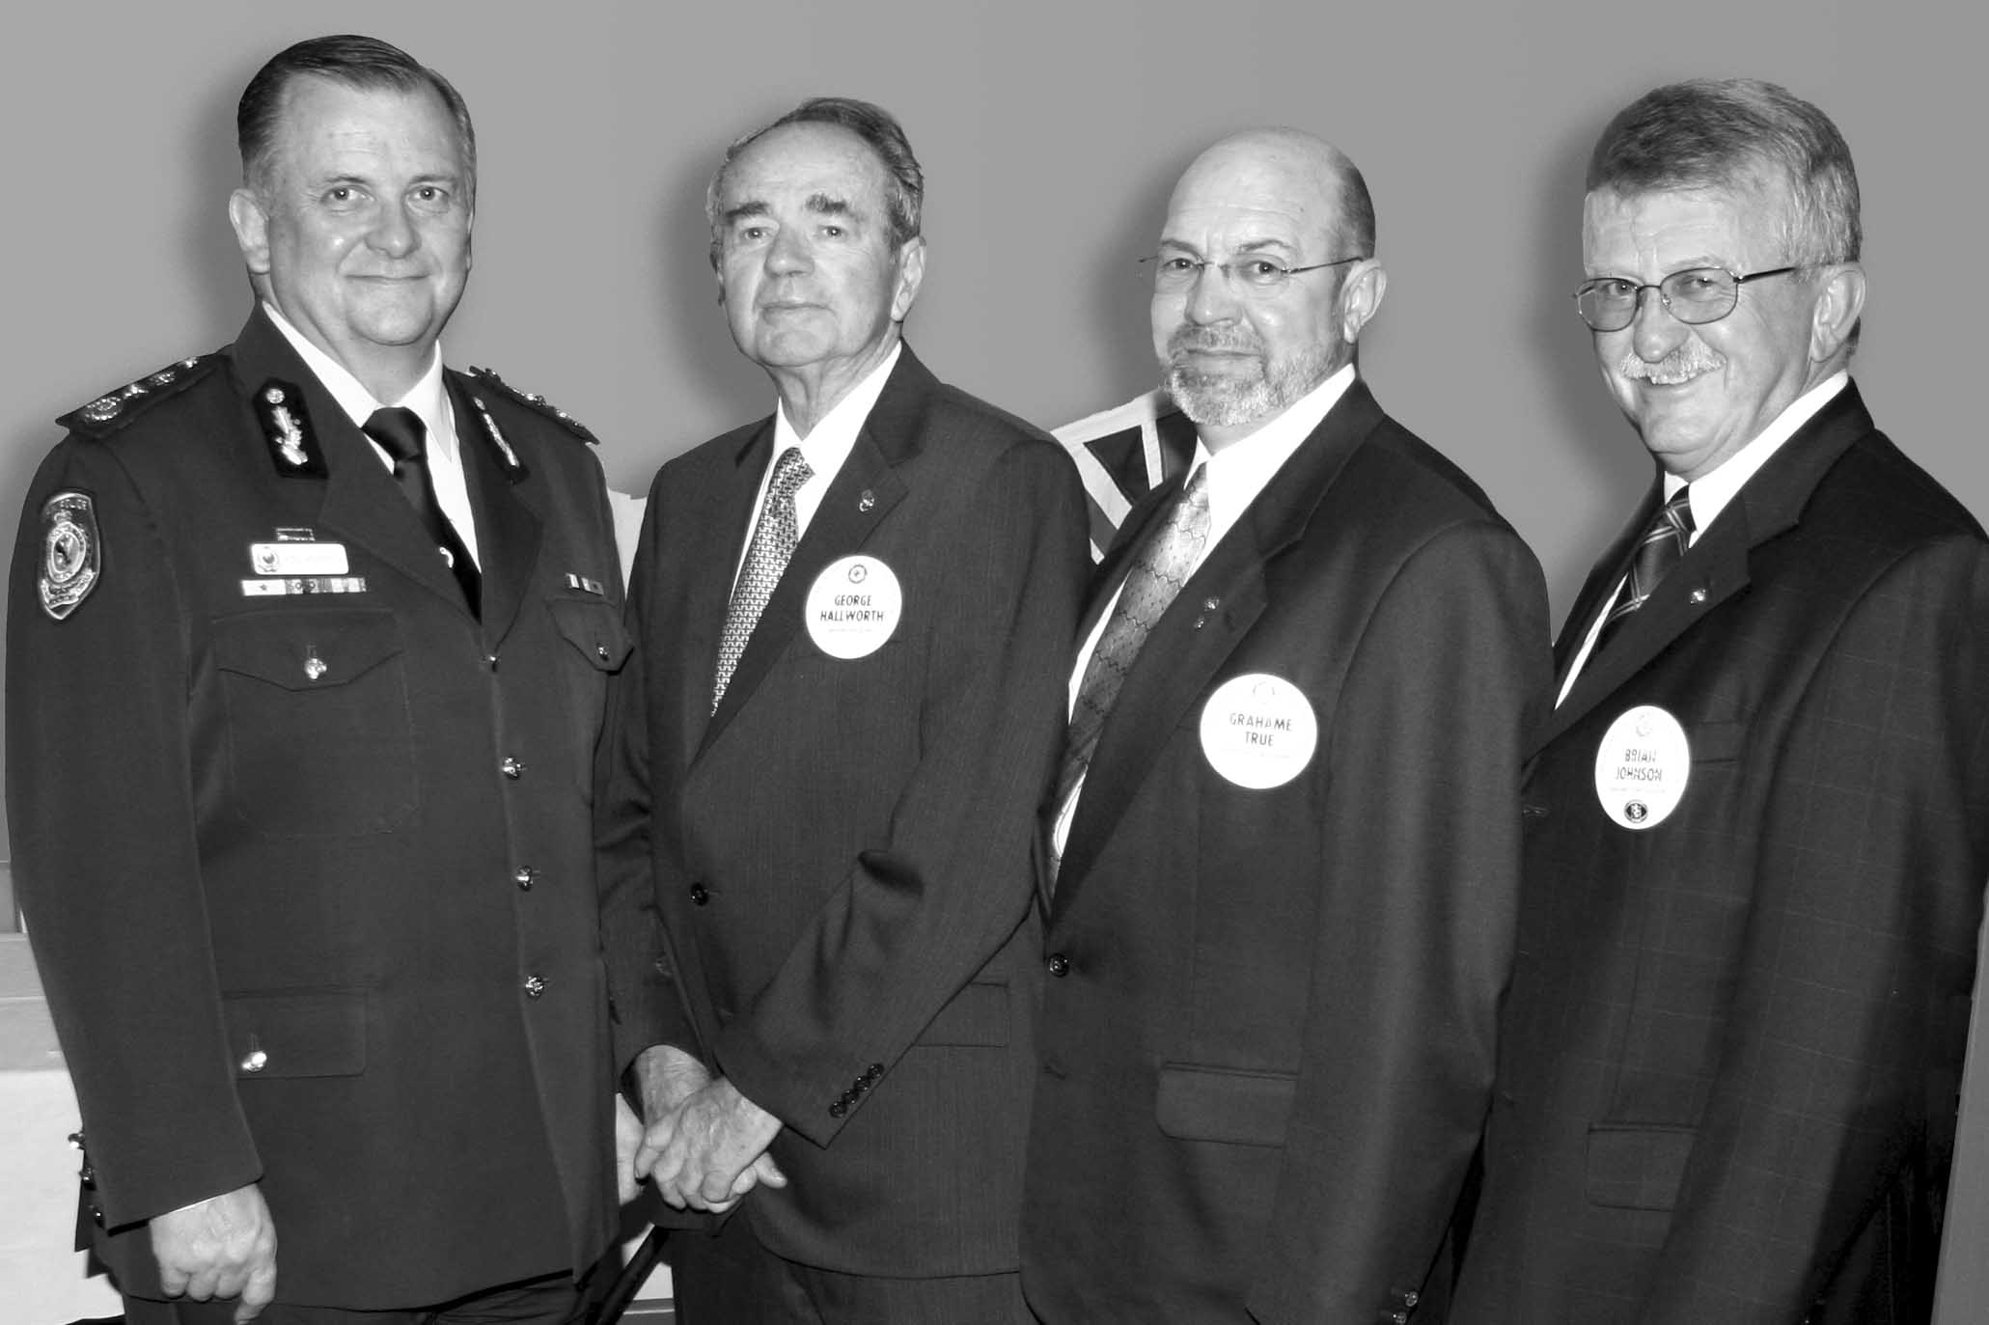
Commissioner Ken Moroney, George Hallworth, Grahame True & Brian Johnson
Last week was the Strathfield Rotary Police Officer of the Year Awards with Commissioner Ken Moroney as our Guest Speaker. Ken Moroney joined the Police Service in 1965. He served in a number of Metropolitan and Rural commands until he became a Director at the Goulburn Police Academy in 1987. Ken recounted his experience of the Thredbo disaster in 1997 wondering where he should begin after a record breaking car trip from Sydney. A Salvation Army volunteer picked up a rock and said “It all starts here”. He became Commissioner in 2002. A report last week from Don Weatherburn of the Crime Commission indicated that Crime Rates are falling due to the efforts of officers such as those here tonight. Ken welcomed the candidates for this year’s awards, who were:-.
FROM BURWOOD AREA COMMAND
- Constable Michelle Broms
- Senior Constable Penny Brown
- Constable Mark George
- Sergeant Scott Hall
- Senior Constable Nicholas Park
- Senior Constable Kristy Toohey
FROM FLEMINTON Area Command
- Constable Mejed El-Dan
- Constable David George
- Constable Leah Greig
- Constable Sally Hogg
- Sergeant Mary Nesbitt
- Sergeant Scott Rendell
- Constable Scott Sinclair
The Police Officer of the Year Award went to Sergeant Scott Hall from Burwood Command and to Constable Sally Hogg from Flemington Command.
Congratulations to Scott and Sally.
Last Week’s Announcements
******************************

From President George Hallworth:-
    - Meeting on Weds. 14th will be at the South Strathfield Bowling Club

From Brian Johnson:-
    - Third Year of running Police Officer of the Year Awards
    - Acknowledged the sponsors who help it happen each year

From Shirley Del Prado:-
    - The BBQ at Ashfield Infants Home last Sat., raised over $1650. Well done BBQ team.

From Directors Kevin Beltrame & Joe Campisi
The Meriden Interact Club had its change over meeting on the 8th September 2005.
The outgoing President, Amanda Stockton, has provided her annual report for our consideration.
Following is a summary of her report:
The Club met every Tuesday during term and Amanda gave thanks to Strathfield Rotary for attending each meeting and providing input when necessary.
During the year funds were raised through: a hamburger day; the Interact dance (attended by Strathfield Rotarians who performed chaperone and BBQ duties); a cake day; selling cornflower pins for Motor Neuron Disease; and helping Rotary with its Trivia night.
Funds were distributed to:
- Cystic Fibrosis NSW $ 250
- Motor Neuron Disease Assoc. $ 600
- St Vincents De Paul Society $2000
The Board for 2005 – 2006 consists of:
President Lauren Moore
Vice President Maz Hannam
Secretary Ellen Stuart
Treasurer Yvette Harapa
Director Alex Tsirekas

From Peter Foss (Trivia Night Organiser):-
Copy of thank you letter from the Principal of Meriden Girls School 23 August 2005:-

Dear Peter,
Thank you for letting me know that your Club was happy with the outcome of the Trivia Night.
Meriden has very strong links with the Strathfield Rotary Club, both through personal association with the members and through the Clubs' work with Interact.
The school is always happy to assist your Club in its activities and it was a pleasure to be able to provide a venue for this function.
The support your members give for our Interact Club both through time and money is very much appreciated.
Yours sincerely
Carolyn Blanden
Principal

Raffle Winners
Raised $875 for Motor Neurone Assoc.
1st Guest Coffee Brewer from George Helou
2nd Ray Wilson Voucher to Rock Salt Menai
3rd Grahame True Necklace & Earrings from Linda Taylor
4th Guest Avon Cosmetics from Connie Lanzafame
5th Denise Taylor Golf Shirt from Ray Wilson
6th Ken Moroney Teacher’s Scotch from Peter Douglas
Coming Events
*****************************

Hawkesbury Charity Race Day
Thurs. 22nd September 2005. Clarendon
Sponsorship/race $3000,
Supporters Package $100/table.

Liverpool Rum Ball
Fri. 23rd September 2005 Roma Function Centre, Liverpool $120pp.

Strathfield Council Spring Fair
Strathfield Park on 9th October 2005

Holroyd Rotary, Charity Golf Day
Fri. 14th October 2005. Fox Hills Golf Club. 7:00am for 8:00am Tee-Off. 1:30pm Lunch. Teams of 4; $110.00pp.

Picnic Day to Yarramalong
Sun. 16th October 2005. Ross Brown Estate.
Open to all Rotarians and friends.

District Golf Day
20th October 2005. Strathfield Golf Club.
Open to all Rotarians and friends,
Contact Ray Wilson.

Pride of Workmanship Awards
23rd November 2005. Partner’s Night 6:30 for 7:00pm.
Lieutenant Colonel Georgeina Whelan, CSC.
Commanding Officer, The Aust. Army

Family of Rotary Afternoon
Children’s function on Sunday 3rd December 2005 at the Marconi Club.

Carols by Candlelight 2005
Strathfield Park
Saturday 10th December 2005.
The committee chairman is Keith Byrn.

Children’s Christmas Party
14th December 2005 at the Golf Club.

Club Christmas Party 2005
21st Dec. 2005 at the Golf Club.
Partners Night.

Charity Golf Day
16th February 2006 at Strathfield Golf Club. Organised by Niall King

District 9690 Conference
April 7th, 8th & 9th 2006. Panthers Convention Centre, Port Macquarie.
Ted Ingall is our Club’s Conference Coordinator

Next Rotary Meeting
**************************
21st September Patricia Boggs
Live Theatre as Entertainment

Future Club Meetings
*****************************
28th September Job Talks. Also presentation of trivia night funds to Jennifer Philps from the Children’s Medical Research Institute (CMRI).
5th October PDG Lloyd Roever
Reaching Overseas Medical Aid for Children ( ROMAC )
12th October Denise Chapman
Epilepsy Association
19th October TBA
26th October Myra Sgorbini
Last Link Organ Donor
2nd November Denis Moore
Circle of Life
9th November Glen Anthony
Motor Cycle Culture.
16th November Brett Moore
Sydney Waterways.
23rd November Pride of Workmanship Awards
Partner’s Night 6:30 for 7:00pm.
Lieutenant Colonel Georgeina Whelan, CSC.Commanding Officer, The Aust. Army
30th November Club Elections TRANSFERRED TO SOUTH STRATHFIELD BOWLING CLUB*
7th December Board to Confirm transfer to the Spanish Inn - Ozzie’s Rest.*

14th December Children’s Xmas Party
21st December Club Xmas Party
(Partners Night)

* NOTE!! Strathfield Golf Club unavailable
Humour from Our Members
**********************************

Politics
From Umesh Kamkolkar
A little boy goes to his dad and asks, "What is Politics'?"
Dad says, "Well Son, let me try to explain it this way; I am the head of the family, so call me The President, Your mother is the administrator of the money, so we call her the Government. We are here to take care of your needs, so we will call you The People. The nanny, we will consider her The Working Class and your baby brother, we will call him The Future. Now think about that and see if it makes sense.
So the little boy goes off to bed thinking about what Dad has said. Later that night, he hears his baby brother crying, so he gets up to check on him. He finds that the baby has severely soiled his diaper. So the little boy goes to his parent's room and finds his mother sound asleep. Not wanting to wake her, he goes to the nanny's room. Finding the door locked, he peeks ill the keyhole and sees his father in bed with the nanny. He gives up and goes back to bed.
The next morning, the little boy say's to his father, "Dad, I think I understand the concept of politics now."
The father says, "Great son! Tell me in your own words what you think politics is all about."
The little boy replies, "The President is screwing The Working Class while The Government is sound asleep. The People are being ignored and The Future is in deep shit."

Life’s Truths
From Steve Taylor
You have two choices in life: You can stay single and be miserable, or get married and wish you were dead.

At a cocktail party, one woman said to another, "Aren't you wearing your wedding ring on the wrong finger?" "Yes, I am. I married the wrong man."

A lady inserted an ad in the classifieds: "Husband Wanted". The next day she received a hundred letters. They all said the same thing: You can have mine."

When a woman steals your husband, there is no better revenge than to let her keep him.

A woman is incomplete until she is married. Then she is finished.

A little boy asked his father, "Daddy, how much does it cost to get married?" Father replied, "I don't know, son, I'm still paying."

First guy says, "My wife's an angel!" Second guy remarks, "You're lucky. Mine's still alive."

A young son asked, "Is it true, Dad, that in some parts of Africa a man doesn't know his wife until he marries her?" Dad replied, "That happens in every country, son."

Then there was a woman who said, "I never knew what real happiness was until I got married, and by then, it was too late."

Marriage is the triumph of imagination over intelligence.

If you want your spouse to listen and pay strict attention to every word you say -- talk in your sleep.

Just think, if it wasn't for marriage, men would go through life thinking they had no faults at all.

HE SAID; SHE SAID
From Steve Taylor
He said: I don't know why you wear a bra; you've got nothing to put in it.
She said: You wear pants don't you?

He said: Shall we try swapping positions tonight?
She said: That's a good idea - you stand by the ironing board while I sit on the sofa and fart!

He said: What have you been doing with all the grocery money I gave you?
She said: Turn sideways and look in the mirror!

He said: How many men does it take to change a roll of toilet paper?
She said: We don't know; it has never happened.

He said: Why is it difficult to find men who are sensitive, caring and Good- looking?
She said: They already have boyfriends.

She said: What do you call a woman who knows where her husband is every night?
He said: A widow.

He said: Why are married women heavier than single women?
She said: Single women come home, see what's in the fridge and go to bed. Married women come home, see what's in bed and go to the fridge.

