Weekly Bulletin





The Rotary Club of Strathfield

PRESIDENT George Hallworth Edition Number: 19
Wednesday 9th November 2005

Website: http://www.rotarnet.com.au/strathfield
November is Rotary Foundation Month

President-Elect Rod’s Chit Chat
********************************
Our guest speaker last week, Denis Moore of Circus of Life, demonstrated that Rotary meetings can be fun!

It was a great night with good attendance, although I have had to report to President George that the meeting overran slightly. Denis reminded us all to keep the child within us alive and the sales of his books at the end of the meeting were clear evidence of how well his talk was received. I should point out, however, that there are no plans for replacement of the sergeant's bell with a honka hooter.

And a goodonya to Ted Ingall for his impromptu demonstration of his skill with a boater hat. I think you may have missed you true vocation, Ted - and you might just have stolen our guest speaker's thunder.

Thanks to all members for providing your acting president with a smooth running meeting (well, there was that one talkative table).

Secretary Roger issued nomination forms for the board elections at the upcoming AGM to be held on Wednesday 7th December. A reminder that the meeting is a transfer meeting and will be held at Ozzies Restaurant. See inside for a nomination form and details of the meeting.

Welcome back to President George who has returned from a short break with batteries recharged and ready to resume control.

Over to you President George.

Acting President Rod
To-Night’s Guest Speaker
*****************************
LATE CHANGE TO BE ADVISED
Congratulations
*****************************

Birthdays
09/11/2005 David Croft
10/11/2005 Jan Van Der Sleesen
11/11/2005 Rick Collins

Anniversaries
15/11/2005 Tony & Connie Lanzafame
Niall & Carole King
Peter & Marley Harries
Last Week’s Visitors
*****************************
Jan Van der Sleesen
Rtn TN Kutty from Ottapalam, India
Last Week’s Guest Speaker
*****************************
Jannelle Watson introduced Dennis Moore who spoke about the Circus of Life, or how to make fun work. Dennis grew up with a family that was part of a traveling fair, providing fun and entertainment in country Australia. He was part of an Indian rope performing team and also helped with the boxing tent. Dennis now provides a consultancy service to make work fun. Humour is a positive force in influencing human behaviour by:-
- Increasing productivity
- Increasing staff retention
- Building relationships
- Improving attendance and loyalty
Dennis quotes Flight Centre who adopted the work is fun approach and achieved a 25% drop in sick leave. Humour or ‘keeping the child inside alive’ improves relationships, especially customer service. A consumer survey found the following main factors is choosing a service provider:-
7% Price 7% Loyalty
9% Range 16%Convenience
24% Ambience 31% Service & Attitude
Bringing fun to your work requires belief in yourself, understanding your humour style and knowing how to do it. Dennis referred to his book on the subject for further reading. Steve Taylor thanked Dennis on behalf of the Club.
Announcements
******************************

From President-Elect Rod McDougall:-
- Seeking nominations for the Strathfield Rotary Board. Elections to be held on 7th Dec.
- Nomination Form available at the back of this Bulletin.
- Welcome back to Sal Tosto

From Secretary Roger Vince:-
- Rotary Xmas Cards circulated for purchase at $10 per pack

From Director Bradley Ayres:-
- Seeking volunteers to provide accommodation for 7 Rotarians from Sweden as part of the Rotary Friendship Exchange (RFE) Program.
- The Club will be hosting the Thai GSE Team from Weds 26/04/06 to 30/04/06. Concord & Burwood Clubs will assist.

From Director Paul Giammarco:-
- Our candidate for the National Youth Science Forum, Nicholas Smith, will attend the Club on 30/11/05

From Director Joe Campisi:-
- Proposed ‘Harry Potter’ Movie night has been cancelled

From Ted Ingall:-
- District Conference registration forms, maps and brochures are now available for the District Conference on April 7th, 8th & 9th 2006.
- The early bird discount ends on 30th Nov.

From Ray Wilson:-
- Lower Blue Mtns Club won the District Shield at last week’s District Golf Day
- Raffle raised $680
- Approx, $4000 raised for District
- Need better effort for Harley next year

From Bert Houston:-
- Pledges for the Xmas Hamper are required to be delivered at the next Rotary meeting.

From Jannelle Watson:-
- Ozzie’s Restaurant donated $100 from their Melb. Cup raffle and three, 10% off vouchers for the restaurant.

Connie Galletta:-
- Nominations for Pride of Workmanship Awards close Weds. 9th Nov.

From Niall King:-
- Special Golf Day on 16th Feb 2006.
- Need sponsors and players

From Tony Lanzafame:-
- John Lanzafame has won first place in the International Pizza Makers Competition. So we now know who to get for a Pizza Night!!

From Rotary World News:-
- The First Ever Afghan GSE Team Visited the USA earlier this year. Six professors from Nangarhar University in Jalabad travelled to the USA as members of Afghanistan’s first GSE team.

From Sergeant Allan Petersen:-
- Used the theme of “Headlines” during the sergeant’s session.

Raffle
The raffle raised $220.⁵⁰, due to the good work of acting raffle man, Kevin Beltrame.
1st Umesh Kamkolkar Floodlamp donated by Grahame True
2nd prize Peter Manenti Dinner next week
3rd Dominic Alvaro Bottle of Wine

Statistics
- $119.25 raised by the Sergeant.
- Present:- 39 Members
- Apologies:- 9
- Non-Apologies:- 5

Coming Events
*****************************

Burwood Rotary YEP Dinner
Monday 14th November 2005. Contact Roger Vince.

Special Rotary Zone Institute Meeting
Hosted by Penrith Valley Rotary. Penrith Panthers Thurs. 17th November 2005. RI President-Elect Bill Boyd will be a guest speaker. Contact Secretary Roger if you wish to attend.

Zonta 25th Year Celebration Dinner
Tuesday 22nd November 2005 at The Greyhound Social Club, Yagoona. 7 for 7:30pm. $30pp, Contact Sandra Gilbert 9709 5490

Pride of Workmanship Awards
23rd Nov 2005. Partners’ Night. 6:30 for 7:00pm.

District BBQ Day
Opening of the M7 Motorway. 27th November 2005. ‘Spaghetti Junction’ (Intersection with M4).

Family of Rotary Afternoon
Children’s function on Saturday 3rd December 2005 at the Marconi Club.

World Swim for Malaria
3rd Dec, donations to Rotarians Against Malaria (RAM). www.worldswimformalaria.com/RotaryAustralia

Carols by Candlelight 2005
Strathfield Park Saturday 10th December 2005.
The committee chairman is Bert Houston.

Children’s Christmas Party
14th December 2005 at the Golf Club.

Club Christmas Party 2005
21st Dec. 2005 at the Golf Club. Partners Night.

GSE Team Farewell
Monday 13th February 2006 at the Springwood Bowling Club. 6:30 for 7:00pm. $25pp.

Charity Golf Day
16th February 2006 at Strathfield Golf Club. Organised by Niall King

District 9690 Conference
April 7th, 8th & 9th 2006. Panthers Convention Centre, Port Macquarie. Ted Ingall Conf Coord

Rotary Awareness Race Day
Saturday 6th May, 2006. Rosehill Gardens. $25 dep. $120, $100, $70 & $25 pp packages. Ray Reed/ Joy Gillett Phn: 9633 4888

2006 Rotary International Convention.
11th -14th June 2006. 97th Rotary International Annual Convention. MalmC6, Sweden and Copenhagen, Denmark. http://www.rotary.org/newsroom/downloadcenter/events/index.html
Next Rotary Meeting
*************************
16th November Brett Moore
Sydney Waterways.

Future Club Meetings
*************************
23rd November Pride of Workmanship Awards
Partner’s Night 6:30 for 7:00pm.
Lieutenant Colonel Georgeina Whelan, CSC.Commanding Officer, The Aust. Army Tsunami Relief Command
30th November Neryla Jolly
School of Applied Vision Services
Vision and Driving Project
Transferred To South Strathfield Bowling Club *
7th December Club Elections Transferred To Ozzie’s Rest @ the Spanish Inn, cnr Homebush Rd & Hume Hwy *

14th December Children’s Xmas Party
21st December Club Xmas Party (Partners Night)
28th December NO MEETING
4th January 2006 NO MEETING
11^{h} January 2006 TBA
18th January 2006 TBA
25^{h} January 2006 TBA
* NOTE!! Strathfield Golf Club unavailable

The New Xmas Cheer
From Allan Petersen
Makes you wonder when the current security madness will stop, don’t you think??
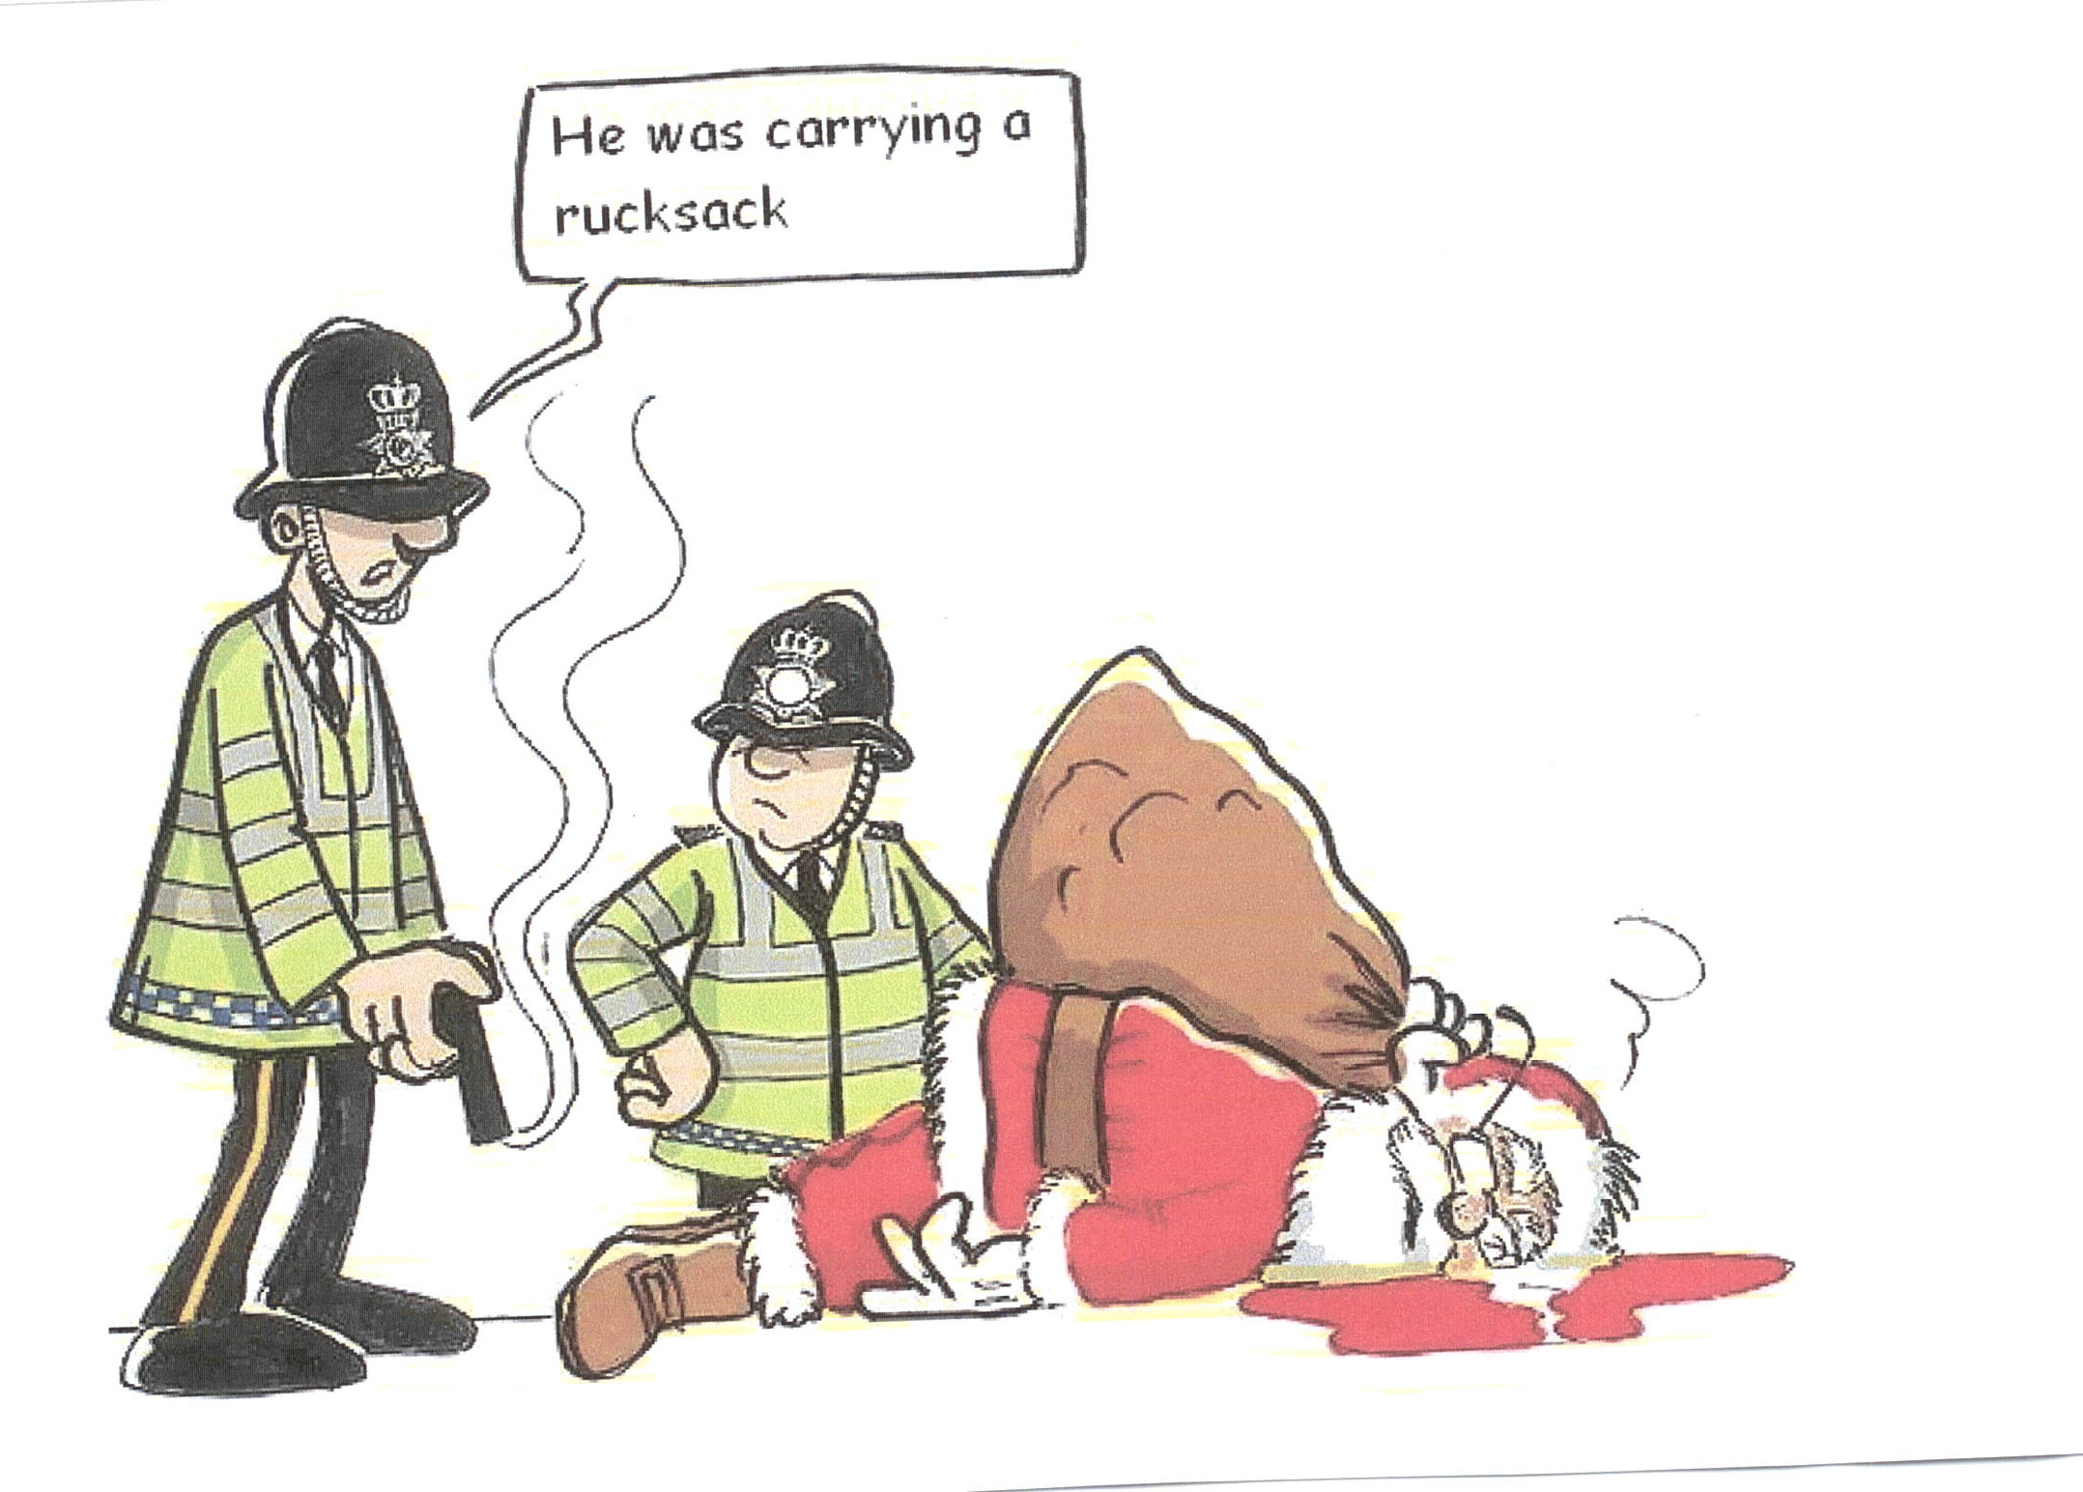
Humour from Our Members
**********************************

The English Language?
From Roger Vince
If you've learned to speak fluent English, you must be a genius! This little treatise on the lovely language we share is only for the brave. Peruse at your leisure, English lovers. Reasons why the English language is so hard to learn:
- The bandage was wound around the wound.
- The farm was used to produce produce.
- The dump was so full that it had to refuse more refuse
- We must polish the Polish furniture.
- He could lead if he would get the lead out.
- The soldier decided to desert his dessert in the desert.
- Since there is no time like the present, he thought it was time to present the present.
- A bass was painted on the head of the bass drum.
- When shot at, the dove dove into the bushes.
- I did not object to the object.
- The insurance was invalid for the invalid.
- There was a row among the oarsmen about how to row.
- They were too close to the door to close it.
- The buck does funny things when the does are present.
- A seamstress and a sewer fell down into a sewer line.
- To help with planting, the farmer taught his sow to sow.
- The wind was too strong to wind the sail
- After a number of injections my jaw got number.
- Upon seeing the tear in the painting I shed a tear.
- I had to subject the subject to a series of tests.
- How can I intimate this to my most intimate friend?
- There is no egg in eggplant nor ham in hamburger; neither apple nor pine in pineapple. English muffins weren't invented in England or French fries in France (Surprise!) Sweetmeats are candies while sweetbreads, which aren't sweet, are meat.
- Quicksand works slowly, boxing rings are square and a guinea pig is neither from Guinea nor is it a pig. And why is it that writers write but fingers don't fing, grocers don't groce and hammers don't ham?
- If the plural of tooth is teeth, why isn't the plural of booth beeth? One goose, 2 geese. So one moose, 2 meese? Doesn't it seem crazy that you can make amends but not one amend. If you have a bunch of odds and ends and get rid of all but one of them, what do you call it? Is it an odd, or an end?
- If teachers taught, why didn't preachers praught? If a vegetarian eats vegetables, what does a humanitarian eat? In what language do people recite at a play and play at a recital? Ship by truck and send cargo by ship? Have noses that run and feet that smell?
- How can a slim chance and a fat chance be the same, while a wise man and a wise guy are opposites? You have to marvel at the unique lunacy of a language in which your house can burn up as it burns down, in which you fill in a form by filling it out, and in which, an alarm goes off by going on.
- English was invented by people, not computers, and it reflects the creativity of the human race, which, of course, is not a race at all. That is why, when the stars are out, they are visible, but when the lights are out, they are invisible.
P.S - Why doesn't "Buick" rhyme with "quick"?

-------------------------------------------------------------------------------------------------------------------------------------------
THE ROTARY CLUB OF STRATHFIELD INC
NOMINATION FORM FOR THE BOARD OF DIRECTORS FOR 2006-2007

Elections to be held at the Annual General Meeting on the 7th December 2005 at the Spanish Inn, cnr Homebush & Liverpool (Hume Hwy) Roads, South Strathfield.

I would like to nominate …………………………………………………for the Board of Directors of the
Rotary Club of Strathfield for the Rotary Year 2006- 2007. . Signed………………………………………

Signed by Nominee: ……………………………………………………….

