Weekly Bulletin





The Rotary Club of Strathfield

PRESIDENT George Hallworth Edition Number: 30
Wednesday 22nd February 2006

Website: http://www.rotarnet.com.au/strathfield
FEBRUARY IS World Understanding MONTH

President George’s Chit Chat
********************************
The Annual Golf Event (is that the right word?) last Thursday was again an outstanding success. Niall King had lot of help, particularly from Ray Wilson, but also from many generous donors and helpers. However, in the final analysis, it was Niall King who put in the hard yards in making the day such a successful one. The rain held off almost long enough for the golfers and the evenings festivities were enhanced by a top smorgasbord and MC Peter Foss and Auctioneer Richard Horwood, who put in stellar performances.

Richard, at his best, in encouraging generous auction bids to benefit MS Research. Final total is not to hand at the time of writing but will be in the vicinity of $18,000. Congratulations to all concerned, especially of course to Niall.

On a sad note, Sal Tosto’s father has passed away. Several Rotarians attended the funeral service at St Anne’s Church in South Strathfield yesterday. Condolences have been sent from the Club.

Full report elsewhere but must say congratulations to Katherine and Joe Campisi on the birth of their son. Well done Joe!

“When the first baby laughed for the first time, the laugh broke into a thousand pieces

and they all went skipping about, and that was the beginning of fairies”
James Matthew Barrie quotes (1860-1937)

Till next week

Enjoy Rotary

President George.
To-Night’s Guest Speaker
*****************************
Jeff Emery
NSW Police
Congratulations
*****************************
Special congratulations to Joe & Katherine Campisi on the birth of their new baby boy.
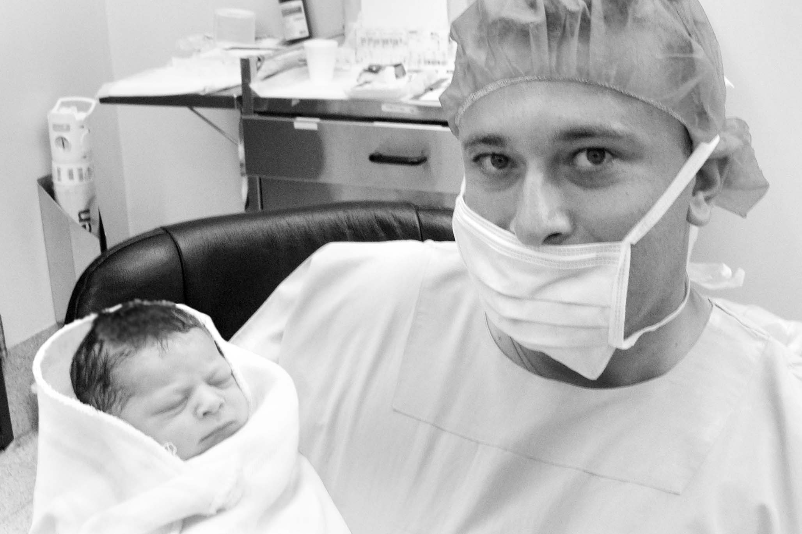 | Vital statistics:  Patrick Christopher,  4.8 kg, 56 cm. Mother and son are both well and now at home

Birthdays
22/02/2006 Anne Manenti
23/02/2006 ROTARY 1905
Bradley Ayres
25/02/2006 Ross Brown
27/02/2006 Brian Driver

Anniversaries
NIL
Sad News
*****************************
Condolences to Sal Tosto and his family on the passing of his father last week.
Last Week’s Meeting
*****************************
The Charity Golf Day Dinner had Peter Foss as the MC for the night. Peter handed over to Niall King and Ray Wilson for the announcement of prize-winners for the golf competition. Prize winner were:-

Nearest the Pin
2nd Hole C. Martlew
7th Hole T. Hickey
13th Hole R. Kirby
12th Hole M. Koureas (8cms)
Runner-Up A. Rowlands

Bradman Trophy (100 runs before lunch)
Roger Vince, Andrew Vince & Charles Pitt

Overall Winners
6th McCluskie Team
5th Carroll Team
4th Koureas Team
3rd Trevewa Team
2nd O’Brian Team
1st Rowland Team

Special Prizes
Unluckiest Shot G. Taniane
Worst Shot B. Abbott
All female players

Major Sponsors
N King Pty. Ltd Peter Manenti
Bentley Sydney Joseph P Saad & Co
Ray Wilson Niall King

Auctions
Richard Horwood ran the live auction and Peter Foss announced the successful bidders for the Silent Auction.

Thank You
A short video on the work of the Trish Research Foundation explained the research undertaken by the Foundation in association with MS Australia. Carol Langsford, a director of the Foundation, thanked Strathfield Rotary, all supporters and in particular Niall King for their efforts. Carol noted the new Aust-genetics Programme and quoted Betty Cuthbert who said of MS “Never give up”.
Raffle Winners
*****************************
1st Prize George Hallworth  2nd Prize Anne Wilson  3rd Prize E. Kellman  4th Prize Anne Manenti  5th Prize Peter Manenti  6th Prize R Avis  7th Prize Shirley del Prado  8th Prize A Saad | 9th Prize Peter Manenti  10th Prize Shirley del Prado  11th Prize Guest  12th Prize Jo Taylor  13^{h} Prize Guest  14th Prize Guest  15th Prize Bob Templeman  16th Prize Angelo Franco
Frank Devlyn PHF Function
*****************************
During Frank's visit to Australia to attend D9690 & D9750 Conferences a function has been arranged at NSW Parliament involving the 3 Sydney Districts. The function is for PHF's only. Frank will give an address in the theatre and meet guests afterwards at a reception. Due to space constraints our District has been allocated 50 seats -first in!! Please bring this invitation to the attention of the PHF's in your club. Ticket applications should be made on the attached form and forwarded to the 9750 coordinator. Any questions re this event should be directed to Foundation Chair, John Wakefield.
Regards DG Bill
Royal Easter Show Volunteers
*****************************
Dear All
Would you please pass this opportunity for service to the community onto your members. Those interested should contact PDG Heinz
Regards DG Bill
Following discussions with the RAS, I write to seek your support in obtaining volunteers for this year's Royal Easter Show, and ask that you "plug" this throughout your District - perhaps your District Secretary can forward this on to your clubs. Those Rotarians (as well as partners and friends) who were volunteers last year (primarily at the Wood Chop) have already been contacted via a letter from the RAS, but I know that there will be others who will be interested in participating in this wonderful event.
As in the past, Volunteers will be provided with a uniform comprising T-Shirt, hat, spray jacket, and carry bag, as well as free entry, meal vouchers and travel concessions. However ALL volunteers must commit to a minimum 6 shifts (either 9am-3pm or 3pm-7pm).
Further details on how to register interest, conditions and guidelines for volunteer workers and compulsory training sessions can be obtained directly from :- Eric Commazzetto or Allison Richards at (02) 9704 1041 or email ecommazzetto@showground.com.au
In the meantime, if you have any questions, please feel free to call me on 0408 223 429.
Your co-operation and support will be greatly appreciated. Yours in Rotary Service
Heinz Gerstl District 9750, PDG 1995-1996

District Conference Update
*****************************
Please let Chairman Ted Ingall know if you need additional accommodation for Thursday 6th or Sunday 9th or any further additions. Ted’s theme for the Conference is “Strathfield Pirates”, black eye-patches, plastic swords and three cornered hast. Get your thinking caps on.
Attendance at the Conference is a ‘MAKE-UP’ before or after the Conference, protecting your membership.
Coming Events
*****************************
Membership Development Night
Wednesday. March 15th. All guests no fee.

District 9690 PETS Conference
Sunday 19th March 2006 at Meriden School.

District 9690 Conference
April 7th, 8th & 9th 2006. Panthers Convention Centre, Port Macquarie. Ted Ingall Conf Coord

GSE Team from Thailand
Wednesday 26 April 2006. Final meeting in Australia before retuning home on the Sunday. Rotarians from Burwood, Concord and Silverwater may also attend

District 9690 Assembly
Sunday 30th April 2006 at Meriden School.

Rotary Awareness Race Day
Saturday 6th May, 2006. Rosehill Gardens. $25 dep. $120, $100, $70 & $25 pp packages. Ray Reed/ Joy Gillett Phn: 9633 4888

2006 Rotary International Convention.
11th -14th June 2006. 97th Rotary International Annual Convention. MalmC6, Sweden and Copenhagen, Denmark. http://www.rotary.org/newsroom/downloadcenter/events/index.html
District 9690 Changeover
Sunday 25th June, 2006. Waterview Convention Centre, Bicentennial Park, Sydney Olympic Park
12.00 noon for 12.30pm.
Next Rotary Meeting
*************************
1 March 2006 Veronica Necyporuk
Chair of Rotarians Against Malaria (RAM)

Future Club Meetings
*************************
8th March 2006 Alfredo le Cava
Pure Gelato
15th March Sheldon Ross
Membership Development
(Board Meeting to Follow)
22nd March 2006 Club Assembly +
Job Talk – Steve Taylor
29th March 2006 Rodney Rietdyk
Mannings Funerals
5th April 2006 Warren Bond
Chair of Rotary Australia World Community Service (RAWCS)
12th April 2006 TBA
19th April 2006 TBA
26th April 2006 GSE Team from Thailand
3rd May 2006 TBA
10th May 2006 Glenn Anthoney
T3 Wireless Ventures
Humour from Our Members
**********************************

Performance Appraisal
From Keith Stockall
A woman meets a gorgeous man in a bar. They talk, they connect, and they end up leaving together. They get back to his apartment and she notices that his bedroom is completely packed with sweet cuddly teddy bears. Hundreds of cute small bears on a shelf all the way along the floor, cuddly medium-sized ones on a shelf a little higher, and huge enormous bears on the top shelf along the wall. The woman is surprised that this guy would have a collection of teddy bears, especially one that's so extensive, but she decides not to mention this to him, and actually is quite impressed by his sensitive side.
She turns to him... they kiss... and then they rip each other's clothes off and make hot steamy love. After an intense night of passion with this sensitive guy, they are lying there together in the afterglow, the woman rolls over and asks, smiling, "Well, how was it?"
The guy says: “Help yourself to any prize from the bottom shelf."

Beer, Fishing, Golf and Sex
From Bradley Ayres
A man was walking down the street when he was accosted by a particularly dirty and shabby-looking homeless man who asked him for a couple of dollars for dinner. The man took out his wallet, extracted ten dollars and asked, "If I give you this money, will you buy some beer with it instead of dinner?"
"No, I had to stop drinking years ago," the homeless man replied.
"Will you use it to go fishing instead of buying food?" the man asked.
"No, I don't waste time fishing," the homeless man said. "I need to spend all my time trying to stay alive."
"Will you spend this on greens fees at a golf course instead of food?" the man asked.
"Are you NUTS!" replied the homeless man. "I haven't played golf in 20 years!"
"Will you spend the money on a woman in the red light district instead of food?" the man asked. "What disease would I get for ten lousy bucks?" exclaimed the homeless man.
"Well," said the man, "I'm not going to give you the money. Instead, I'm going to take you home for a terrific dinner cooked by my wife."
The homeless man was astounded. "Won't your wife be furious with you for doing that? I know I'm dirty, and I probably smell pretty disgusting."
The man replied, "That's okay. It's important for her to see what a man looks like after he has given up beer, fishing, golf, and sex."

Perspective??
From Grahame True
A father passing by his son's bedroom was astonished to see that the bed was nicely made and everything was picked up. Then he saw an envelope propped up prominently on the center of the bed. It was addressed "dad". With the worst premonition, he opened the envelope and read the letter with trembling hands:
Dear Dad,
It is with great regret and sorrow that I'm writing this. I had to elope with my new girlfriend because I wanted to avoid a scene with mum and you. I’ve been finding real passion with Barbara and she is so nice even with all her piercing, tattoos, and her tight motorcycle clothes. But it's not only the passion dad, she's pregnant and Barbara said that we will be very happy. Even though you don't care for her, as she is much older than I, she already owns a trailer in the woods and has a stack of firewood for the whole winter. She wants to have many more children with me and that's now one of my dreams too. Barbara taught me that marijuana doesn't really hurt anyone and we'll be growing it for ourselves and trading it with her friends for all the cocaine and ecstasy we want. In the meantime, we'll pray that science will find a cure for aids so Barbara gets better; she sure deserves it!! Don’t worry dad, I’m 15 years old now and I know how to take care of myself. Someday I’m sure we'll be back to visit, so you can get to know your grandchildren.
Your son, John
P.S. Dad, none of this is true. I’m over at the neighbor's house. I just wanted to remind you that there are worse things in life than my report card which is in my desk center drawer.
I love you! Call when it's safe for me to come home.

Consultants
From Keith Stockall
A timeless lesson on how consultants can make a difference for an organization. Last week, we took some friends out to a new restaurant, and noticed that the waiter who took our order carried a spoon in his shirt pocket. It seemed a little strange. When the busboy brought our water and utensils, I noticed he also had a spoon in his shirt pocket. Then I looked around and saw that all the staff had spoons in their pockets. When the waiter came back to serve our soup I asked, "Why the spoon?"
"Well," he explained, "the restaurant's owners hired Andersen Consulting to revamp all our processes. After several months of analysis, they concluded that the spoon was the most frequently dropped utensil. It represents a drop frequency of approximately 3 spoons per table per hour. If our personnel are better prepared, we can reduce the number of trips back to the kitchen and save 15 man-hours per shift." As luck would have it, I dropped my spoon and he was able to replace it with his spare. "I'll get another spoon next time I go to the kitchen instead of making an extra trip to get it right now." I was impressed.
I also noticed that there was a string hanging out of the waiter's fly. Looking around, I noticed that all the waiters had the same string hanging from their flies. So before he walked off, I asked the waiter, "Excuse me, but can you tell me why you have that string right there?"
"Oh, certainly!" Then he lowered his voice. "Not everyone is so observant. That consulting firm I mentioned also found out that we can save time in the restroom. By tying this string to the tip of you know what, we can pull it out without touching it and eliminate the need to wash our hands, shortening the time spent in the restroom by 76.39 percent.
I asked "After you get it out, how do you put it back?"
"Well," he whispered, "I don't know about the others, but I use the spoon."

