

Weekly Bulletin

The Rotary Club of Strathfield .


Edition Number: 33

PRESIDENT Keith Byrn
Wednesday 16th March 2005

Website: http://www.rotarnet.com.au/strathfield

THE Centenary Year OF Rotary

President Report
******************************
Greetings Fellows,
Last week we again had the pleasure of listening to another quality guest speaker in Rory Nash. Rory could have addressed us for hours with his fascinating approach to life & motivation.
Thanks again go to Richard Horwood who continues to provide us with the best of guest speakers.

Well it’s finally here. The Rotary conference in Canberra is on this weekend. Many who are attending will be heading to Canberra tomorrow in anticipation of a great conference with many and varied activities and conference agenda items in store for us.
Anyone who still has any questions or queries regarding the conference please see or contact Ted Ingall who I am sure can provide you with an answer. Thanks go to Ted for all of his arranging. I am sure he will sleep well once the Conference activities are done.

DON’T FORGET, THOSE WHO ARE ATTENDING, THAT THE SATURDAY NIGHT GALA DINNER AT PARLIAMENT HOUSE IS BLACK TIE.

Our meeting the following Wednesday 23/3/05 is a transfer meeting to Westmead Children’s Hospital. The visit is primarily for the hospital to show our Club Members how they have used the funds that we have donated over the last couple of years.
Please try and attend as I know we will be made very welcome. That’s all for now, I am looking forward to seeing everyone at the Conference,
And until then,

LET’S CELEBRATE ROTARY,

President Keith.

NOTE!!!! For Next Week Transfer Meeting to Westmead Children’ Hospital. (details p3)

This Week’s Guest Speaker
******************************
Malcolm Little OAM
St. Johns Ambulance

Congratulations
******************************

Special Congratulations to our two new members, Dr. Umesh & Anuradha Kamkolkar on their induction into our Club at last week’s meeting.

Birthdays
17/03/2004 Joan Brown
20/03/2004 Roy Smidt
21/03/2004 A Bala
24/03/2004 Harley Tarrant
Guru Singh

Anniversaries
22/03/2004 Maree McDougall
23/03/2004 Joe & Sharon Saad
24/03/2004 Anne & Roy Smidt

Last Week’s Guest Speaker
******************************
Rory and Michele Nash were introduced to the Club by Kevin Beltrame. Rory spoke about “Success Masters”, while Michele operated the computer and overheads. Rory & Michele conduct training sessions and talks for Business and Personal solutions. Rory began his talk by comparing the path to success to the Rotary Four Way Test in that they both have the same premises. Rory uses his “Ah-Ha” test.
A Attitude (The primary skill for success)
H Honesty (secrets = problems)
H Heart (sincerity in actions)
A Action (follow through)
Attitude adopted to a problem is your choice; no one can force you to act.
Honesty is essential to effective problem solving for both the presenter and the listener.
Heart is the sincerity of the message and of the listener.
Action is necessary to implement the processes decided.
Rory and Michele provide their sessions to a variety of people including CEO’s, executives, substance-dependants and relationships.
Euan Watson thanked both Rory and Michele for their talk.

Last Week’s Announcements:-
******************************

From President Keith Byrn:-
- Welcome back to Ted Ingall
- Thank you to George Hallworth for filling in at last week’s meeting
- Saturday Night Dinner at the Conference is a Black Tie dinner.

From Secretary Tony Lanzafame: -
- Letter from Homebush Meals-on-Wheels thanking the Club for $600 donation.

From Director Kevin Beltrame: -
- Strathfield Youth Awards will be held at the Golf Club on Weds. 13th April 2005 and is a partner’s night.

From Director Bradley Ayres: -
- The GSE team will be at the Concord Rotary Meeting on Monday 21st March. Any members wishing to attend to contact Bradley.
- Received a letter from Lyn Testa advising of the Rotary “Centurion Club” for members donating $100 for the Rotary Foundation.

From Kevin Freund: -
- An invitation from Mr. Wardana, Consul General of The Republic of Indonesia, to a night at the Parade Theatre on Tues., 15th March 2005. Contact Kevin for details

From Rod M^{c}Dougall: -
- Sponsors needed for the Bike-The-Park Fund Raiser.

From Euan Watson: -
- WS FM is major sponsor for Bike the Park.
- Volunteers needed to distribute fliers to bike shops for Bike the Park on first Sunday in May.

Raffle
The raffle raised $232.00.
1st prize Connie Galletta- -Golf Shirt & Book
2nd prize Ray Wilson -Bottle of wine
3rd prize Peter Harries- -Dinner next week

Statistics
- $117.60 raised by the Sergeant.
- 12 apologies
- 1 non apologies

Coming Events
******************************
Meriden School Dance
Friday 18th March 2005 at the Meriden School Hall. Chaperones/BBQ operators required at 6:30pm. Director Kevin Beltrame.
District 9690 Conference
18th – 20th March 2005 at the National Convention Centre Canberra.
Late Final Extra from Chairman Ted Ingall.
District Conference Information details to help you find your way to CROWN PLAZA HOTEL AND CONVENTION CENTRE/CASINO.
Follow Northbourne Av. Information Centre on left after Morphett St. Continue to London Circuit, turn left at the fifth street on the left in Constitution Av. First left into Allara St., which becomes Binara St. Crown Plaza on the right-hand-side before Glebe Park.
If confused obtain a Canberra Map (Details per favour Mary Ingall).
Suggestions:-
- Collect your registration kit from the Convention Centre as early as possible.
- Bus is available to transport Crown Plaza patrons to Saturday Dinner at Parliament House.
- Remember Saturday night Ball at Parliament House in the Great Hall is a BLACK TIE. Dinner Suit is suggested.
- Remember to take your swimming costume as the Crown Plaza has a solar heated pool.
- Congratulations, we have 28 Rotarians plus 25 partners/friends. Total of 53 registrations plus Madeline Ayres (21 months)
- For additional information, read extracts from the DG’s letter distributed at last week’s meeting.

Happy Motoring and see you at the Conference.

Ted Ingall
Bike the Park
(Sydney Olympic Park Bike Ride)
Sunday 1st May 2005. Contact Rod McDougall / Steve Taylor for details.
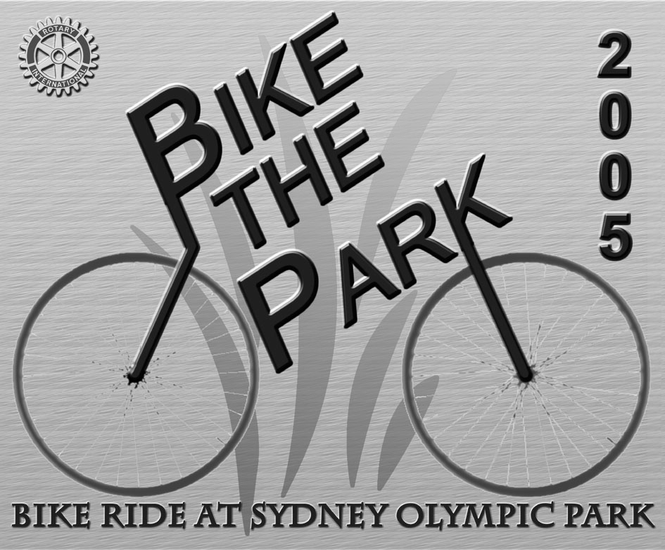

District Assembly
For the Incoming Board on Sun. 15th May 2005 at St. Mary’s High School.

Trivia Night

Fri. 12th August at Meriden School. Organised by Brian Hennell

Club Xmas Party 2005
Fri. 9th Dec. 2005 at the Golf Club as a transfer meeting. Partners Night.

Next Rotary Meeting
******************************
23rd March 2005 Professor David Bennett *Transfer Meeting* to Westmead Children’s Hospital. Main Entrance at 6:00pm. Intro at 6:10pm. Dinner in Bear’s Brassiere at 6:30pm.

Future Club Meetings
******************************
30th March 2005 Helen Griffiths
CEO Cystic Fibrosis NSW
6th April 2005 Kelly Baker & Noel Noble
ParaQuad NSW
13th April 2005 Strathfield Youth Awards
Partners night, 6:30pm for 7:00pm
29th June 2005 CLUB CHANGEOVER
27th July 2005 2005/2006 DG’s visit at the Golf Club. Partners Night. , 6:30pm for 7:00pm
10th August 2005 Tri-District Meeting at the Strathfield Golf Club. Rotary Information Night
(Date to be confirmed)

Humour from Our Members
********************************

The Pope and the driver
From Joe Campisi & Allan Petersen
After getting all of Pope John Paul's luggage loaded into the limo, (and he doesn't travel light), the driver notices that the Pope is still standing on the curb.
"Excuse me, Your Holiness," says the driver, "Would you please take your seat so we can leave?"
"Well, to tell you the truth," says the Pope, "they never let me drive at the Vatican, and I'd really like to drive today."
"I'm sorry but I cannot let you do that. I'd lose my job! And what if something should happen?" protests the driver, wishing he'd never gone to work that morning.
"There might be something extra in it for you," says the Pope.
Reluctantly, the driver gets in the back as the Pope climbs in behind the wheel.
The driver quickly regrets his decision when, after exiting the airport, the Pontiff floors it, accelerating the limo to 105 mph.
"Please slow down, Your Holiness!!!" pleads the worried driver, but the Pope keeps the pedal to the metal until they hear sirens.
"Oh, dear God, I'm going to lose my license," moans the driver. The Pope pulls over and rolls down the window as the cop approaches, but the cop takes one look at him, goes back to his motorcycle, and gets on the radio.
"I need to talk to the Chief," he says to the dispatcher.
The Chief gets on the radio and the cop tells him that he's stopped a limo going a hundred and five.
"So bust him," says the Chief.
"I don't think we want to do that, he's really important," said the cop.
The Chief exclaimed, “All the more reason!"
"No, I mean really important," said the cop.
The Chief then asked, "Who you got there, the Mayor?"
Cop: "Bigger."
Chief: "Governor?"
Cop: "Bigger."
"Well," said the Chief, "Who is it?"
Cop: "I think it's God!"
Chief: "What makes you think it's God?"
Cop: "He's got the Pope as a chauffeur!!"

SHOULD CHILDREN WITNESS CHILD BIRTH???
From Joe Campisi
Due to a power outage at the time, only one paramedic responded to the call. The house was very, very dark, so the paramedic asked Katelyn, a 3-year old girl, to hold a flashlight high over her mommy so he could see while he helped deliver the baby.
Very diligently, Katelyn did as she was asked. Heidi pushed and pushed, and after a little while Connor was born.
The paramedic lifted him by his little feet and spanked him on his bottom.
Connor began to cry. The paramedic then thanked Katelyn for her help and asked the wide-eyed 3-year old what she thought about what she had just witnessed.
Katelyn quickly responded, "He shouldn't have crawled in there in the first place. Smack him again."

TO ALL THE KIDS WHO SURVIVED the 1930's, 40's, 50's, 60's and 70’s!!
From Allan Petersen
First, we survived being born to parents who smoked and/or drank while they carried us. They took aspirin, ate blue cheese dressing and didn't get tested for diabetes.
Then after that trauma, our baby cribs were covered with lead-based paints. We had no childproof lids on medicine bottles, doors or cabinets and when we rode our bikes we had no helmets, not to mention the risks we took hitchhiking.
As children, we would ride in cars with no seat belts or air bags. Riding in the back of a Ute on a warm day was always a special treat.
We drank water from the garden hose and NOT from a bottle. We shared one soft drink with four friends, from one bottle and NO-ONE actually died from this.
We ate cupcakes, bread and butter and drank soft drink with sugar in it, but we weren't overweight because WE WERE ALWAYS OUTSIDE PLAYING!
We would leave home in the morning and play all day, as long as we were back when the streetlights came on. No-one was able to reach us all day. And we were okay.
We would spend hours building our Billy-carts out of scraps and then ride down the hill, only to find out we forgot the brakes. After running into the bushes a few times, we learned to solve the problem.
We did not have Play stations, Nintendo's, X-boxes, no video games at all, no 180 channels on cable, no video tape movies, no surround sound, no cell phones, no personal computers, no Internet or Internet chat rooms and some of us didn't have TV sets WE HAD FRIENDS and we went outside and found them!
We fell out of trees, got cut, broke bones and teeth and there were no lawsuits from these accidents.
We made up games with sticks and tennis balls and ate dirt, snails and worms and although we were told it would happen, we did not put out very many eyes, nor did the worms live in us forever.
We rode bikes or walked to a friend's house and knocked on the door or rang the bell, or just walked in and talked to them!
Footy and cricket had tryouts and not everyone made the team. Those who didn't had to learn to deal with disappointment. Imagine that!!
We went to the beach on our own and nobody drowned. We learnt to be responsible for what we did and if it warranted it we got punished by our parents.
The idea of a parent bailing us out if we broke the law was unheard of. They actually sided with the law! And told us we got what we deserved!
This generation has produced some of the best risk-takers, problem solvers and inventors ever! The past 50 years have been an explosion of innovation and new ideas.
We had freedom, failure, success and responsibility, and we learned HOW TO DEAL WITH IT ALL!
You might want to share this with others who have had the luck to grow up as kids, before the lawyers and the government regulated our lives for our own good.
Kind of makes you want to run through the house with scissors, doesn't it?!

